Asssignment No -: 05

Que 1-: Write A Query That will give you all orders for more than Rs. 1000.

kd2_83598>select onum,odate,cnum,snum from orders
-> where amt>=1000;

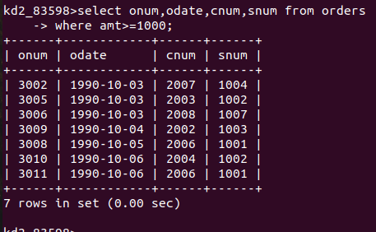

Que 2 -: Write a query That will give you the names And cities of all salespeople in a london with commission above .10 .

kd2_83598>select sname,city from salespeople
-> where city='london' and comm>0.10;
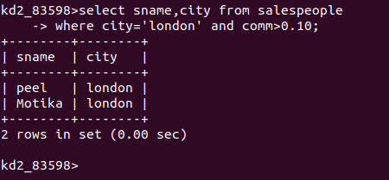

que 3 -: Write A query on customers table whose output will exclude all customers with a rating <=100, unless they are located in rome.

kd2_83598>select cnum,cname,snum from Customers
-> where City='Rome' and Rating>100;

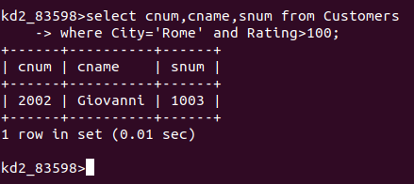

Que 4-: Output of the Query

kd2_83598>select *from orders
-> where (amt<1000 or
-> Not (odate='1990-10-03' and cnum>2003));

First this bracket will evaluate because of precedence of brackets and 'AND' operator,

(odate='1990-10-03' AND cnum > 2003) and here the rows which satisfy both of these commands (odate = '1990-10-03'), (cnum > 2003) will be excluded and remaining rows are displayed and then after that, outside brackets command will be considered which is, OR (amt < 1000), where all the commands which are less than 1000 will be selected and displayed, irrespective of the condition that they satisfy these commands(odate = '1990-10-03' AND cnum > 2003).

Que 5-: output of the Query.

kd2_83598>select *from orders
-> where Not((odate='1990-10-03' or snum>1006) and amt>=1500);

First this bracket will evaluate because of precedence of brackets and 'AND' operator,

(odate='1990-10-03' OR snum >1006) and here the rows which satisfy either of these commands

(odate='1990-10-03'), (cnum > 2003) will be excluded and remaining rows are displayed) and (both should satisfy) (rows which satisfy, AND (amt >= 1500)),

Que 6-: Simpler Way to Write The Query
select snum,sname,city,comm from salespeople
where(comm >.12 Or comm<.14);

kd2_83598>select *from salespeople
